**BUSINESS PLAN**

MPU 22012

ENTREPRENEURSHIP

GROUP 1

MRZ_PASTA

DET4C

|  |  |
| --- | --- |
| MUHAMMAD AQIL LUQMAN BIN NOIDAN | 03DET22F1035 |
| CHONG KHENG CHEN | 03DET22F1043 |
| NURUL AFIKAH BINTI AZHAR | 03DET22F1039 |

6.BACKGROUND OF PARTNER

|  |  |  |  |
| --- | --- | --- | --- |
| NAME | MUHAMMAD AQIL LUQMAN BIN NORIDAN | CHONG KHENG CHEN | NURUL AFIQAH BINTI AZHAR |
| ID NUMBER | 041217080429 | 041104020083 | 040319020238 |
| ADDRESS | No.401, Lorong 8/2, Taman Siswa 2, Jitra Kedah | 97, TAMAN BERJASA JALAN SULTAN ABDUL HALIM 05400 ALOR SETAR KEDAH | NO 35, JALAN DATO KERAMAT, TAMAN SRI AMAN, KUBANG PASU, 06000, KEDAH |
| TELEPHONE NUMBER | 0195796244 | 019-4972588 | 01139488474 |
| FORM OF BUSINESS | PARTNERSHIP | PARTNERSHIP | PARTNERSHIP |
| DATE OF BIRTH AND AGE | 17/12/2004  20year old | 4-11-2004  20year old | 19/03/2004  20year old |
| ACADEMICS QUALIFICATION | SPM | SPM | SPM |
| COURSE ATTENDED |  | ELETRIC ENGINEERING |  |
| SKILLS | BARTENDER | MARKETING | CHEF |
| PRESENT OCCUPATION & EXPERIENCE |  |  |  |

7.LOCATION OF THE BUSINESS

Company Name: MRZ.PASTA

Address: 27, TAMAN SRI UTAMA JITRA 06000 KEDAH

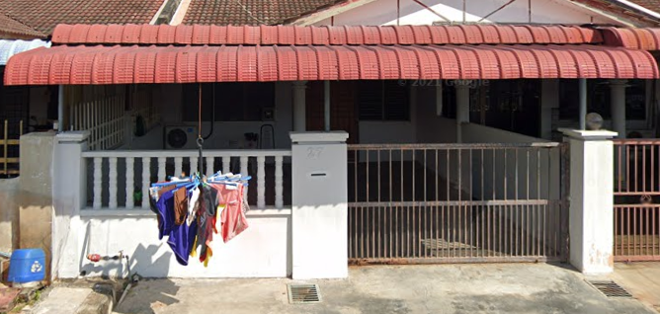Phone: 019-497 2588

Email: mrz.pasta@gmail.com

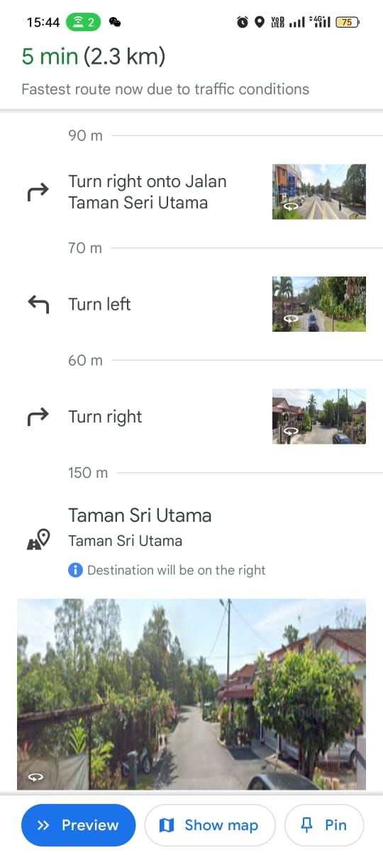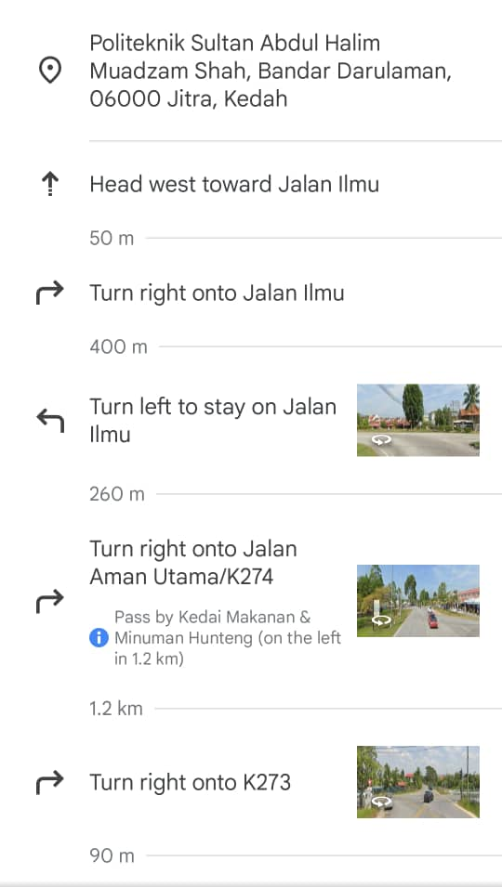

8.ADMINTRATION PLAN

**Mission, Vision, and Objectives:**

Mission: Provide high-quality, gourmet food products to delight customers.

Vision: Become a trusted household name known for culinary excellence.

Objectives: Expand product line, increase market share by 15% annually.

**Organizational Chart**

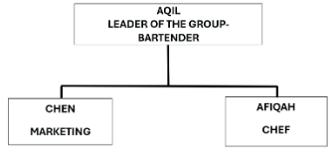

**MANPOWER PLANNING**

Roles and Responsibilities: Define the specific roles needed for the operation of your business. This might include positions such as chefs/cooks, servers, cashiers.

Skill Requirements: Identify the skills and qualifications necessary for each role. For example, chefs should have culinary training or experience, while servers should have good communication and customer service skills.

Scheduling: Develop a staffing schedule that ensures adequate coverage during all operating hours while minimizing labor costs. Consider factors such as employee availability, preferences, and legal requirements regarding breaks and overtime.

Contingency Planning: Have plans in place for handling unexpected staffing shortages, such as illness or sudden increases in demand. This might involve cross-training employees to perform multiple roles or having a pool of on-call staff available as backup.

**SCHEDULE OF TASK AND RESPONSIBILITIES**

Market Research:

Understand who our customers are and what they like.

Check out other pasta and soda sellers to see what they're doing.

Business Planning:

Figure out how much money we need and where to get it.

Make sure we follow all the rules and regulations for selling food.

Supplies and Ingredients:

Find good ingredients for our pasta and soda.

Make sure we always have enough stuff to make our products.

Product Development:

Create tasty pasta dishes and soda flavors.

Ask people to try our food and tell us what they think.

Marketing and Sales:

Tell people about our pasta and soda through ads and promotions.

Make it easy for customers to buy from us, whether online or in person.

Getting Ready to Open:

Find a good location for our business.

Hire and train staff to help run things smoothly.

Promotion:

Offer special deals to attract customers.

Keeping Track and Improving:

Keep an eye on how well we're doing and what customers are saying.

Make changes to our business based on what we learn.

Growing the Business:

Look for ways to expand, like opening more stores or adding new menu items.

Make sure we're doing our part for the environment and our community.

**REMUNERATION PLAN**

Hourly Pay or Salary: Employees get paid for their time worked.

Sales Bonuses: Staff earn extra for selling more.

Profit Sharing: Employees get a cut of the profits as the business succeeds.

Discounts: Staff get discounts on pasta and soda.

**LIST OF OFFICE EQUIPMENT AND SUPPLIES**

Office Equipment:

Computers: Desktops or laptops for administrative tasks, inventory management, and accounting.

Printers/Scanners/Copiers: For printing invoices, scanning documents, and making copies of important paperwork.

Furniture: Desks, chairs, and tables for office workstations .

Stationery: Pens, pencils, notepads, and other writing essentials.

Staplers and Staples: For securing paperwork and documents.

File Folders and Organizers: For keeping paperwork and documents organized.

Labels and Label Maker: For labeling inventory, files, and storage containers.

Calculator: For basic accounting and calculations.

Whiteboard/Flipchart: For brainstorming, planning, and keeping track of tasks.

Cleaning Supplies: To maintain a clean and tidy workspace.

Kitchen Equipment (for pasta and soda preparation):

Refrigeration Units: To store ingredients, sauces, and beverages.

Cooking Equipment: Pots, pans, and utensils for cooking pasta dishes.

Ice Maker: For keeping drinks cold and refreshing.

Food Storage Containers: To store prepared ingredients and leftovers.

Safety Equipment:

Fire Extinguishers: For fire safety.

First Aid Kit: For minor injuries and emergencies.

**ADMINISTRATIVE BUDGET**

Staff Costs: Salaries for administrative employees.

Office Expenses: utilities, and supplies.

Communication: Phone and internet bills.

Technology: Software and hardware costs.

Miscellaneous: Unexpected expenses.

9. MARKETING PLAN

**Description of products:**

Pasta Types:

We offer classic pasta types like spaghetti and penne, along with specialty options such as gluten-free and organic.

Soda Selection:

Our soda lineup includes popular brands like ICE CREAM SODA, as well as local craft sodas in unique flavours.

Quality and Sourcing:

We prioritize high-quality ingredients sourced from trusted suppliers, ensuring freshness and taste in every bite and sip.

Packaging:

Our products come in convenient, eco-friendly packaging that reflects our commitment to sustainability.

Price and Sizes:

Prices vary based on product and size, with options for individual servings or bulk purchases to accommodate different needs and budgets.

**Target markets and segments:**

Target audience: College students living on or near campus.

Segmentation: Based on dietary preferences, budget constraints and convenience needs.

**Market size:**

There are approximately 8,000 students within a 5-mile radius of campus.

**Competitor analysis:**

Advantages: high brand awareness and convenient location.

Cons: Limited healthy options, higher prices.

**Market share:**

It currently occupies 20% of the student food market.

**Sales Forecast:**

The goal is to capture 30% of the market in the first year and grow revenue by 15% annually thereafter.

**Marketing strategy:**

Social Media Presence: Engage on Instagram, TikTok through menu highlights, recommendations.

Campus Activities: Final Year Project

Loyalty program: Offers discounts for repeat purchases.

Online Ordering: Develop user-friendly website, mobile application for ease of use.

Content Marketing: Provide nutritional tips, lifestyle content to build trust.

**Marketing budget:**

Spread the Word: Budget for ads, flyers, or events to let people know about your products.

Offer Deals: Allocate funds for discounts or promotions to attract customers.

Let Them Try: Set aside money for letting people taste your products.

Share Content: Invest in creating useful content like recipes or tips related to your products.

10.PRODUCTION PLAN

**Operation Process:**

Source fresh ingredients, prepare meals, package, and deliver to campus locations.

**Production Schedule/Capacity Planning:**

Daily schedule based on demand forecasts and kitchen capacity.

**Material Requirements:**

List of ingredients and packaging materials needed for each menu item.

**Machine and equipment:**

Pasta Making Equipment:

Pasta cooker: For boiling pasta.

Kitchen Equipment:

Oven, stove, and fridge: For cooking and storing ingredients.

Tables, sinks, and dishwasher: For food preparation and cleaning.

Soda Dispensing Equipment:

Soda fountain dispenser: To serve soda.

CO2 tanks and syrup pumps: For carbonation and flavoring.

Packaging and Serving Equipment:

Containers, cups, and lids: For packaging pasta and soda.

Safety and Sanitation Equipment:

Fire extinguisher and first aid kit: For emergencies.

Cleaning supplies: For maintaining cleanliness.

Furniture and Decor:

Tables, chairs, and decor: For customer seating and ambiance.

**Location of operation:**

Busy Spot: Find a place where lots of people are around, like downtown.

Pasta Fans: Look for areas where people like pasta and soda, like downtown where workers and tourists often look for quick meals.

Check the Competition: See if there are already a few pasta places around. If not, it could be a good spot.

Near Other Fun Stuff: Pick a place near other popular spots like stores or parks.

**Operation layout plan:**

Sourcing Ingredients:

Buy pasta and soda supplies from wholesalers.

Food Preparation:

Set up kitchen stations for pasta making and soda preparation.

Keep track of ingredient levels and reorder when necessary.

Menu Development:

Create a menu with popular pasta dishes and soda flavors.

Customer Service:

Train staff to take orders and handle payments efficiently.

Use a simple POS system for order processing.

Packaging and Presentation:

Use eco-friendly containers for takeout orders and branded cups for sodas.

Marketing and Promotion:

Use social media to showcase menu items and offer discounts.

**Operational Cost and Cost Per Unit:**

Operational Costs:

Rent, utilities, ingredients, labor, and other expenses: RM 200per month

Units Produced:

Pasta: 50 servings per month

Soda: 30 bottles per month

Cost Per Unit:

Pasta: RM 8 per serving

Soda: RM 5 per bottle

**Operational Budget:**

Revenue Projection:

Estimate monthly sales income.

Cost of Goods Sold (COGS):

Calculate the cost of ingredients for pasta and soda, plus packaging.

Operating Expenses:

Include rent, utilities, insurance, licenses, marketing, equipment upkeep, and transportation.

Miscellaneous Expenses:

Set aside funds for unexpected costs and professional services.

Net Income (or Loss):

Calculate net income by subtracting total expenses from total revenue